1. Cloud Network Architecture Review
Cloud network architecture represents a fundamental shift from traditional on-premises infrastructure, introducing new paradigms in security, scalability, and operational efficiency. This section examines the architectural foundations of cloud-native networking, comparing modern Virtual Private Cloud (VPC) implementations with traditional perimeter-based approaches. Through analysis of tier separation, traffic flow patterns, and security controls, we establish the framework for understanding contemporary cloud network security.

1.1 Architecture Overview & Topology
The proposed cloud network architecture implements a robust 3-Tier Virtual Private Cloud (VPC) design. This architecture prioritizes defense-in-depth security, strict separation of duties, and high availability by spanning resources across two Availability Zones.
The network topology is segmented into three distinct logical tiers, ensuring that traffic flows securely from the internet to the web layer, then to the application logic, and finally to the data store, with no direct access permitted between the internet and the data tier.

High-Level Network Diagram:
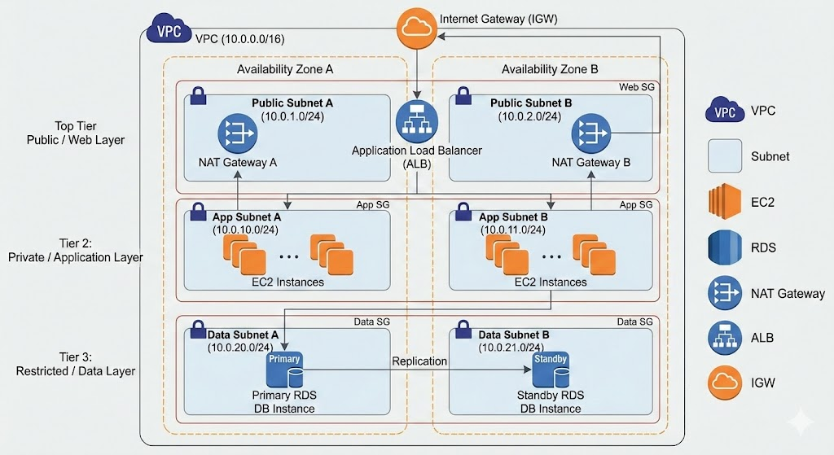

Data Flow Diagram:
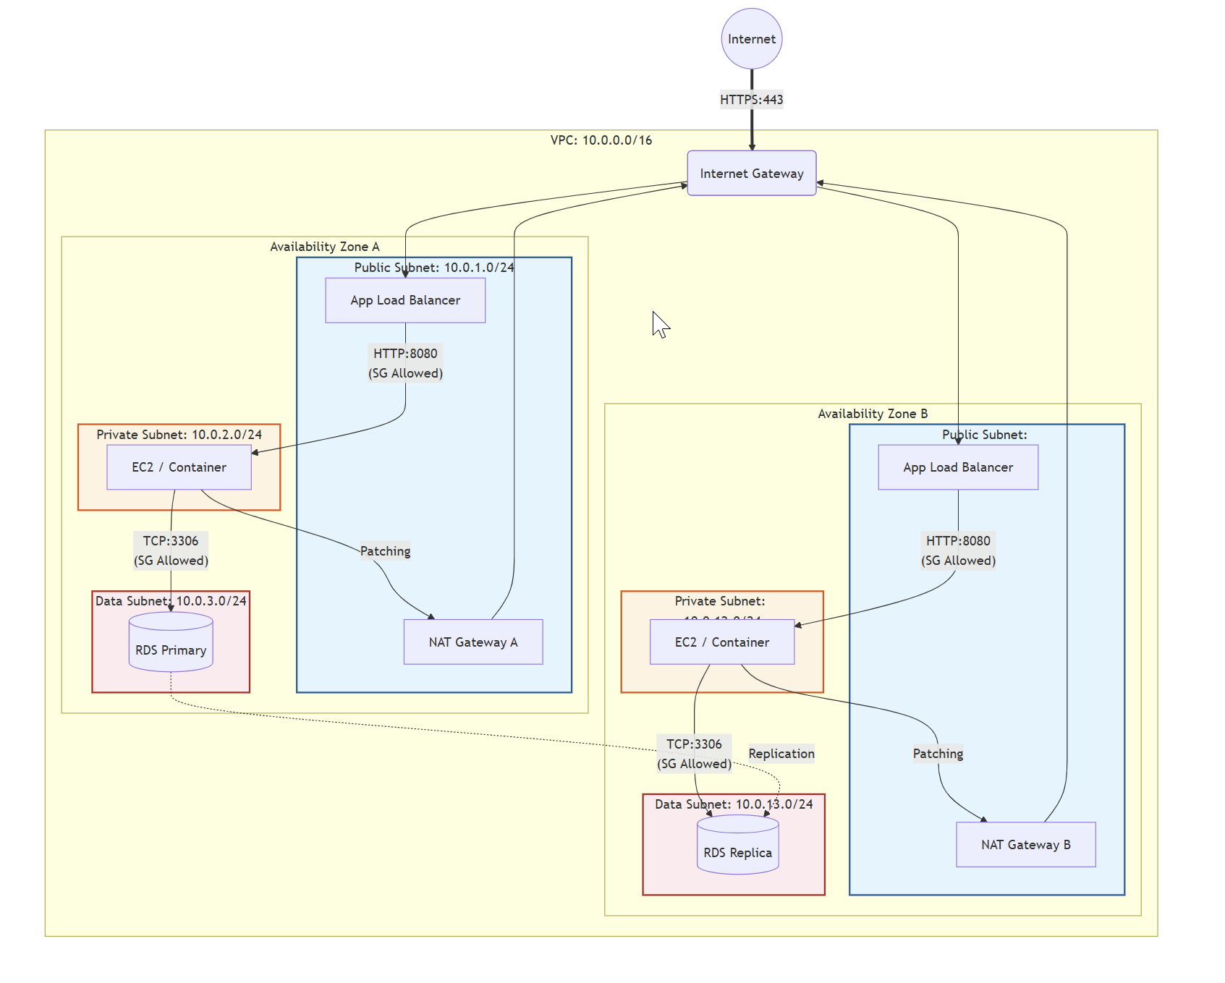Tier Definitions & Connectivity: The following table details the purpose and connectivity profile for each tier within the architecture:

Tier | Type | Purpose | Connectivity Profile
Web Tier | Public | Hosts Application Load Balancers (ALB) and Bastion Hosts/VPN endpoints. | Inbound: Internet (via IGW).  Outbound: Internet.
App Tier | Private | Hosts application servers, container workloads (EKS/ECS), or backend logic. | Inbound: Web Tier only.  Outbound: Internet via NAT Gateway (strictly for patches/APIs).
Data Tier | Private | Hosts RDS databases, ElastiCache, or Redshift clusters. | Inbound: App Tier only.  Outbound: None (or restricted S3 endpoints).

1.2 Security Boundaries: Cloud-Native DMZ Analysis
Unlike traditional on-premise networks that rely on physical "Edge DMZs" and hardware firewalls, this architecture utilizes a Cloud-Native Implementation of security boundaries. This approach shifts the focus from physical isolation to logical separation and micro-segmentation.
Comparison of Security Boundaries:
- Isolation Model:
  - Traditional: Relies on physical network segments or VLANs enforced by core switches.
  - Cloud-Native: Uses Logical Separation via subnets defined by IP CIDR blocks and Route Tables. While this allows for rapid deployment, it requires strict route table management to prevent "leaks" that could accidentally expose private subnets to the internet.
- Ingress Filtering (Layer 3/4):
  - Traditional: Utilizes high-capacity perimeter hardware firewalls.
  - Cloud-Native: Implements a dual-layer defense using Network ACLs (NACLs) at the subnet boundary (stateless) and Security Groups at the instance boundary (stateful). This provides "Defense-in-Depth," where Security Groups act as a distributed firewall for every network interface (ENI).
- Micro-segmentation:
  - Traditional: Complex to implement, often requiring internal firewalls for every server group.
  - Cloud-Native: Security Groups natively support Zero Trust principles. For example, "Server A" and "Server B" in the same subnet can be blocked from communicating unless explicitly allowed, reducing the blast radius of a potential compromise.

1.3 Traffic Flow & Egress Analysis
The architecture dictates strict traffic flow rules to maintain security integrity, particularly regarding outbound (egress) traffic from private resources.
Egress Architecture (NAT Gateway): To allow private instances (App Tier) to download essential updates without exposing them to the internet, the architecture employs NAT Gateways located in the Public Subnets.
- Routing Logic: Traffic originates from the Private Instance, routes through the Private Route Table to the NAT Gateway, and finally exits via the Internet Gateway. The NAT Gateway performs Source NAT (SNAT), replacing the private IP with its Elastic IP.
- Inbound Protection: The NAT Gateway is stateful; it allows return traffic only for connections initiated from inside the VPC. Any unsolicited connection attempts from the internet are automatically dropped, effectively shielding private instances from direct inbound scans.
Design Justification (Gateway vs. Instance): The decision to use a managed NAT Gateway rather than a NAT Instance is based on operational resilience and security:
- Availability: NAT Gateways are fully managed and highly available, scaling automatically to 100 Gbps.
- Security Posture: While NAT Instances allow for custom hardening (e.g., iptables), they represent an additional attack surface that the user must patch and manage. A compromised NAT Instance gives an attacker control over the egress point. The managed NAT Gateway operates as a "black box," making it significantly harder to compromise directly.

1.3.1 NAT Gateway Implementation
- NAT Gateway Configuration Steps
  - Allocation: Create a NAT Gateway in the Public Subnet. It requires an Elastic IP (EIP) to communicate with the internet.
  - Route Table Modification (Private): Update the Route Table associated with the Private Subnet (App Tier). Add a route for 0.0.0.0/0 (all internet-bound traffic) pointing to the nat-gateway-id.
  - Route Table Modification (Public): Ensure the Public Subnet Route Table has a route for 0.0.0.0/0 pointing to the Internet Gateway (IGW). The NAT Gateway resides here and uses this path to exit the VPC.
  - Security Groups (App Tier): Configure the App Tier Security Group to allow outbound traffic to 0.0.0.0/0 (or specific IPs) on ports required for updates (e.g., TCP 80/443).
  - Validation: Traffic originates from the Private Instance -> Private Route Table -> NAT Gateway (Public Subnet) -> Internet Gateway -> Internet. The NAT Gateway performs Source NAT (SNAT), replacing the private IP with its EIP.
- Inbound Traffic Blocking
  - Stateful Nature: The NAT Gateway automatically tracks the state of outbound connections. It allows return traffic only for connections initiated from inside the VPC.
  - Unsolicited Inbound Drop: Any unsolicited traffic connection attempt from the internet to the NAT Gateway's Elastic IP is dropped by default, as there is no internal mapping for it. This effectively shields private instances from direct inbound scans.

1.3.2 Security Controls and Risk Mitigation
- Data Exfiltration Risks (Unmonitored NAT)
  - Unrestricted Egress: Standard NAT Gateways allow all outbound traffic to valid destinations. A compromised instance can connect to a Command & Control (C2) server or upload data to an external storage bucket.
  - Lack of Filtering: NAT Gateways operate at Layer 3/4. They do not inspect payloads or filter by domain name (FQDN). Malware can use standard ports (443) to hide malicious traffic.
  - Recommendation: Implement VPC Flow Logs to monitor traffic metadata. For stricter control, use AWS Network Firewall or a transparent proxy (e.g., Squid) in conjunction with the NAT Gateway to filter outbound traffic by FQDN (e.g., allow *.ubuntu.com, block everything else).
- Comparison: NAT Gateway vs. NAT Instance
  - Availability & Management:
    - NAT Gateway: Fully managed, highly available service. AWS handles redundancy and scaling. No patching required.
    - NAT Instance: A standard EC2 instance running NAT software. The user is responsible for OS patching, scaling, and handling failover (e.g., using scripts to remap routes if the instance dies).
  - Security Posture:
    - NAT Gateway: "Black box" security. Cannot install custom security agents or inspect traffic directly on the gateway. Harder for an attacker to compromise the gateway itself.
    - NAT Instance: Can be hardened with custom iptables rules, DLP agents, or proxy software. However, it is an additional attack surface; if compromised, the attacker controls the egress point.
  - Performance:
    - NAT Gateway: Scales automatically to 100 Gbps.
    - NAT Instance: limited by the instance type's network bandwidth.
  - Recommendation: Use NAT Gateway for most production workloads due to reduced operational overhead and higher resilience. Use NAT Instances only if specific, cost-sensitive, low-throughput, or custom traffic inspection use cases (that cannot be met by other services) are required.

